**Project Design Phase-II**

**Solution Requirements (Functional & Non-functional)**

|  |  |
| --- | --- |
| Team ID | **PNT2022TMID17612** |
| Project Name | Smart Fashion Recommender Application |

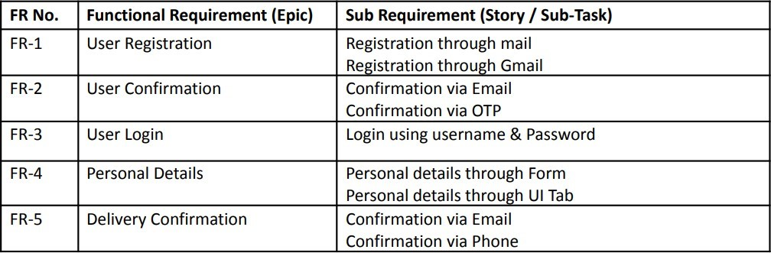

**Functional Requirements:**

Following are the functional requirements of the proposed solution.

**Non-functional Requirements:**

Following are the non-functional requirements of the proposed solution.

